# Mobile Testing

## What are mobile platforms on the market that you know?

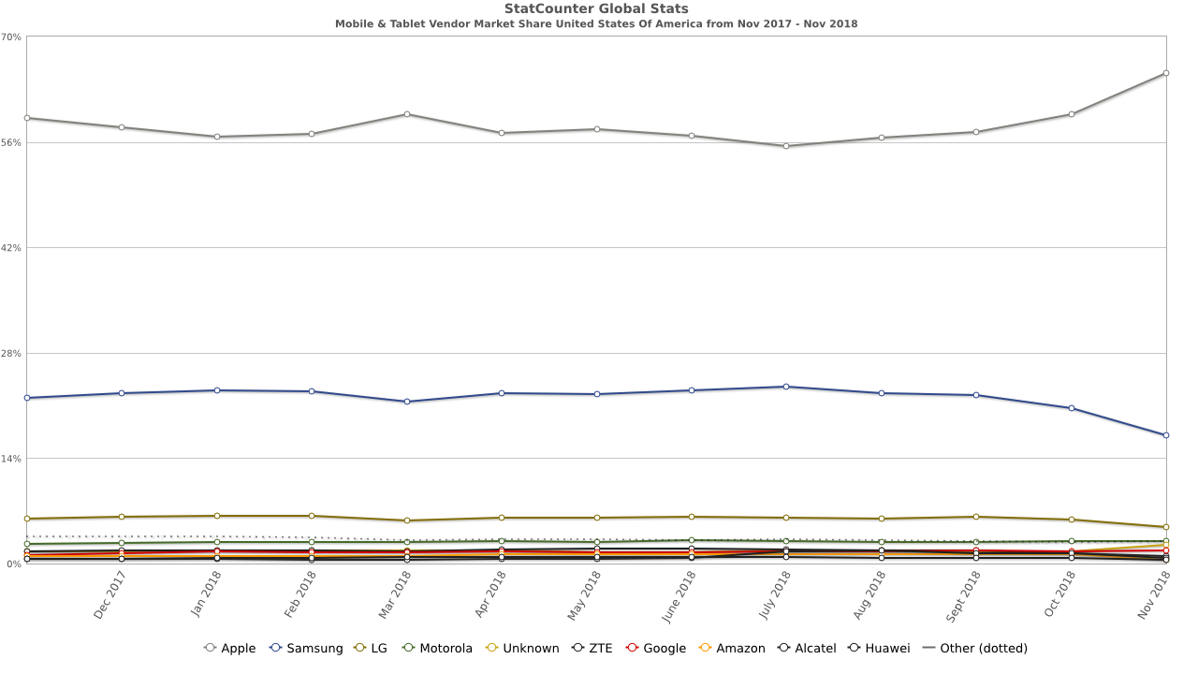[Source](http://gs.statcounter.com/os-market-share/mobile/united-states-of-america/#monthly-201711-201811)

## What Mobile Browsers do you know?

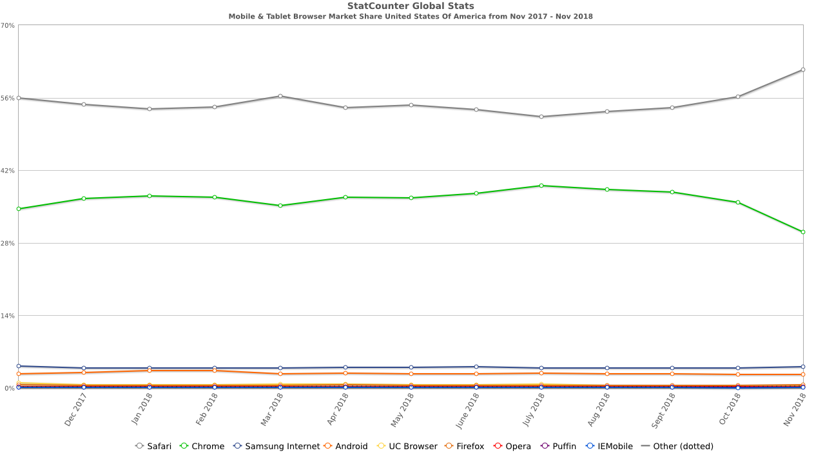

## What is the difference between Web Application and Mobile Application Testing?

Testing mobile applications is different and more complex than testing traditional desktop and web applications. Mobile applications need to be tested on a variety of software platforms and versions, on diverse hardware and form factors, and under different network connectivity conditions. Moreover, the rapid pace of mobile OS updates, the frequent introduction of new devices and the customer expectation of quick upgrades require additional test cycles.

A comprehensive mobile application testing strategy is essential for getting your applications to market on time and within budget. Key elements to consider for effectively testing applications are:

• Target Device Selection – Create an optimal mix of simulator testing and physical device testing on different models to maximize test coverage.

• Test Automation – Select an effective test automation tool and maximize the use of automation to reduce the cost of regression testing.

• Network Environment – Consider testing primarily on Wi-Fi networks and using network simulation tools to simulate cellular connectivity and various network conditions.

• Types of Testing – Consider different types of testing required (functional, performance, security, and compliance).

The challenge of mobile application testing can be effectively addressed by a test strategy that combines these elements with traditional best practices and processes for testing.

## How do you usually explore the new Mobile Device or Phone?

- I’m Reading information in Internet.

- I’m Watching video from presentation of this Device

- I'm Reading the manual documentation which comes with Device

## How do you start Mobile Application Testing?

A typical end-to-end mobile testing process, should start from creating test cases of the application, performing user acceptance and finally device testing stage. See more at: <http://www.rapidvaluesolutions.com/mobile-application-testing-step-by-step-approach/#sthash.fSTDkojz.dpuf>

## Name the specific types of Mobile Testing

Mobile application testing is a process by which application software developed for handheld mobile devices is tested for its functionality, usability and consistency. Device Interoperability Testing is one of the specific types of Mobile Testing to ensure that your mobile app/site functions as intended over a wide range of environments.

## Name 3 types of Mobile testing domains

When we talk about testing in Mobile domain, it is not only confined to Mobile Apps, but also includes mobile handset and mobile website testing.

* Downloadable Mobile Application Testing: — Some applications come pre-installed in mobile handset while some mobile applications are downloadable from different mobile application stores (Apple App store, Android Market, Getjar, Nokia Ovi Store, Blackberry  App world etc.). Apart from conventional Functional and UI testing, you may need to test your application against the submission criteria and guidelines provided by these Application stores. Tester’s role here should not be only functional testing of mobile app, but also to make sure your application adheres to the guidelines provided by these mobile app stores.
* Mobile Handset Testing: Similar to Organizations that develop third party downloadable mobile applications, there are many companies that develop complete mobile handset. A mobile QA here may need to test native applications or features that are available in the phone. SMS, MMS, Voice Call, MMS, Phonebook, Calculator, Bluetooth and other mobile features. It also includes Multimedia (Camera, Video, Media player, ringtones) and Mobile Protocol stack testing.
* Mobile Website Testing (WAP Sites): Unlike downloadable mobile applications, mobile websites can be accessed via browser. No download involved. Testing of Mobile WAP sites has its own challenges. Proper navigation, good user interfaces (design), security, performance and mobile browser compatibility are important areas. Outdated

## How would you test the following: you send Yahoo message from your mobile device to someone else device and recipient doesn’t receive a message? Provide at least 3 ideas of troubleshooting

1. Check your Sent Mail. Messages that you send should appear in your Sent Mail. Is the email address is valid and correct?
2. Verify the recipient has internet connection
3. Confirm you don't have a security conflict caused by your firewall and/or antivirus software. To see if this is the problem, temporarily disable your security software, but remember to turn it back on when you're done testing. Try sending/receiving your email. If you are able to send/receive now, then you need to adjust/update your security software.
4. Double check that the email box isn't full. If it is, you won't be able to send (or receive) emails until you make room.
5. Ask the person you emailed to check his or her junk/spam/trash mail folders for the missing message
6. Verify that sent attachments do not exceed available size limit
7. check the settings in both email accounts, is account is still active and not being suspended?

# Technology

## What does SDK stand for?

SDK stands for Software Development Kit. It is a suite of tools that help to create software.  It generally can include things like an API (application programming interface, a codebase that acts a sort of “go-between” for the programming language and the operating system), an IDE (integrated development environment, a program used to write/manage your code, for example Eclipse or MS Visual Studio), as well as other utilities, like debuggers, etc.  
 A software development kit (SDK or "devkit") is typically a set of [software development](http://development) tools that allows the creation of [applications](http://software) for a certain [software](http://software) package, [software framework](http://framework), hardware platform, [computer system](http://system), [video game console](http://console), [operating system](http://system), or similar development platform. To create applications, you have to download a specific software development kit. For example, the development of an Android app requires an SDK with Java, for [iOS](http://ios) apps an iOS SDK with Swift, and for [MS Windows](http://windows) the [.NET Framework SDK](http://sdk) with .NET. There are also SDKs that are installed in apps to provide analytics and data about activity. Prominent examples include [Google](http://google) and [Facebook](http://facebook).

It may be something as simple as the implementation of one or more [application programming interfaces](http://interface) (APIs) in the form of some libraries to interface to a particular [programming language](http://language) or to include sophisticated hardware that can communicate with a particular [embedded system](http://system). Common [tools](http://tool) include debugging facilities and other [utilities](http://program), often presented in an [integrated development environment](http://environment) (IDE). SDKs also frequently include sample code and supporting technical notes or other supporting documentation to help clarify points made by the primary reference material.

## What is an Operating System?

**OS** is system software that manages computer hardware and software resources and provides common services for computer programs. The operating system is a component of the system software in a computer system. OS is program that, after being initially loaded into the computer by a boot program, manages all the other programs in a computer. The other programs are called applications or application programs. The application programs make use of the operating system by making requests for services through a defined application program interface (API). In addition, users can interact directly with the operating system through a user interface such as a command language or a graphical user interface (GUI).

**Mobile operating system** (OS  is an operating system that is specifically designed to run on mobile devices such as mobile phones, smartphones, PDAs, tablet computers and other handheld devices.  A mobile OS is similar to a standard OS , but is relatively simple and light and primarily manages the wireless variations of local and broadband connections, mobile multimedia and various input methods.

## What is ‘unlocked’ phone?

The difference between a locked and an unlocked phone is that a locked device has a software code on it that prevents you from taking a GSM-based device and using it on another GSM carrier's network. An unlocked phone either doesn't have the lock software on it or someone was able to get a code that unlocks the software. Once a device is unlocked, you can pop out the SIM card and put in a different SIM from another GSM operator and get service.

## What is Cloud Computing to you?

The first thing you should understand about the cloud is that it is not a physical thing. The cloud is a network of servers, and each server has a different function. Some servers use computing power to run applications or "deliver a service."

Other servers in the network are responsible for storing data. For example, when you take a picture on your smartphone, it is stored on your phone's internal memory drive. However, when you upload the photos to Instagram, you are uploading it to the cloud. Chances are, you encounter the cloud daily. From Google Drive to SkyDrive to iCloud to Evernote, any time you store information without using up your phone's internal data, you're storing information on the cloud.

IT people talk about three different kinds of cloud computing, where different services are being provided for you.

* Infrastructure as a Service (**IaaS**) means you're buying access to raw computing hardware over the Net, such as servers or storage. Since you buy what you need and pay-as-you-go, this is often referred to as utility computing. Ordinary web hosting is a simple example of IaaS: you pay a monthly subscription or a per-megabyte/gigabyte fee to have a hosting company serve up files for your website from their servers.
* Software as a Service (**SaaS**) means you use a complete application running on someone else's system. Web-based email and Google Documents are perhaps the best-known examples. Zoho is another well-known SaaS provider offering a variety of office applications online.
* Platform as a Service (**PaaS**) means you develop applications using Web-based tools so they run on systems software and hardware provided by another company. So, for example, you might develop your own ecommerce website but have the whole thing, including the shopping cart, checkout, and payment mechanism running on a merchant's server. Force.com (from salesforce.com) and the Google App Engine are examples of PaaS.

## Where an LBS (location based service is used?

Some examples of location-based services are:

* Recommending social events in a city[[1]](https://en.wikipedia.org/wiki/Location-based_service#cite_note-qr10-1)
* Requesting the nearest business or service, such as an ATM, restaurant or a retail store
* Turn by turn navigation to any address
* Assistive Healthcare Systems[[27]](https://en.wikipedia.org/wiki/Location-based_service#cite_note-27)
* Locating people on a map displayed on the mobile phone
* Receiving alerts, such as notification of a sale on gas or warning of a traffic jam
* Location-based mobile advertising
* Asset recovery combined with active RF to find, for example, stolen assets in containers where GPS would not work
* contextualizing learning and research
* Games where your location is part of the game play, for example your movements during your day make your avatar move in the game or your position unlocks content.
* Real-time Q&A revolving around restaurants, services, and other venues

For the carrier, location-based services provide added value by enabling services such as:

* Resource tracking with dynamic distribution. Taxis, service people, rental equipment, doctors, fleet scheduling.
* Resource tracking. Objects without privacy controls, using passive sensors or RF tags, such as packages and train boxcars.
* Finding someone or something. Person by skill (doctor), business directory, navigation, weather, traffic, room schedules, stolen phone, emergency calls.
* Proximity-based notification (push or pull). Targeted advertising, buddy list, common profile matching (dating).
* Proximity-based actuation (push or pull). Payment based upon proximity (EZ pass, toll watch), automatic airport check-in.

## How familiar you are with Apple devices? Name at least 4, that are currently on the market?

Macbook Air

Macbook Pro

iPad (tablet)

iPod (portable media player and multi-purpose pocket computer)

iPhone 6S

Apple TV

## Why do we need ‘Flight Mode’ on Mobile Device? What is it for?

Airplane mode disables a device’s cellular radio, Wi-Fi, and Bluetooth — the wireless transmission functions.

Regulations in many countries prohibit the use of devices that transmit signals on commercial aircraft. A typical phone or cellular-enabled tablet is communicating with several cell towers and attempting to maintain a connection at all times. If the towers are far away, the phone or tablet has to boost its signal so it can communicate with the towers. This sort of communication could interfere with an airplane’s sensors and potentially cause issues with sensitive navigation equipment. That’s a concern that brought these laws about, anyway. In reality, modern equipment is robust. Even if this does cause problems, your plane won’t fall out of the sky because a few people forgot to enable airplane mode!

A more demonstrable concern is that, as you’re traveling very quickly, all the phones on the plane would be constantly handing off from cell tower to cell tower. This would interfere with the cellular signals people on the ground receive. You wouldn’t want your phone to do this hard work, anyway — it would drain its battery and it wouldn’t be able to maintain a signal properly, anyway.

# Native, Hybrid, Web

## Give me an example of Hybrid Application and describe the Native and Web parts of the application?

A hybrid mobile app takes an HTML mobile app and inserts it inside a native wrapper.

Examples of Hybrid Apps: Twitter, Yelp, Amazon Cloud Reader, Netflix.

Native app is the one that is specifically designed to run on a device’s operating system.Native apps are built for a specific SDK platform, tools and languages.

A Web app is built using HTML5 technology that describe the latest generation of Web standards, including HTML, CSS, and JavaScript, along with several dozen other technologies.They don’t need to be downloaded and installed on the device.

## What are two main differences between mobile native and mobile web app?

Major difference is in how they accessed: mobile web is simply a website (start it in browser);

native app must be downloaded and installed on the devices from app store.

## Provide at least 2 examples for each Category: Mobile application, Mobile Native application, Mobile Web application, Mobile Hybrid application?

1. Mobile Native application: Instagram, Angry Birds, Shazam  
2. Mobile Web applications: Facebook web app, YouTube Web app  
3. Mobile Hybrid applications: Yelp, Twitter

# Android

## What do you know about Android OS?

Android is a [mobile operating system](https://en.wikipedia.org/wiki/Mobile_operating_system) developed by [Google](https://en.wikipedia.org/wiki/Google). It is based on a modified version of the [Linux kernel](https://en.wikipedia.org/wiki/Linux_kernel) and other [open source](https://en.wikipedia.org/wiki/Open-source_software) software, and is designed primarily for [touchscreen](https://en.wikipedia.org/wiki/Touchscreen) mobile devices such as [smartphones](https://en.wikipedia.org/wiki/Smartphone) and [tablets](https://en.wikipedia.org/wiki/Tablet_computer). In addition, Google has further developed [Android TV](https://en.wikipedia.org/wiki/Android_TV) for televisions, [Android Auto](https://en.wikipedia.org/wiki/Android_Auto) for cars, and [Wear OS](https://en.wikipedia.org/wiki/Wear_OS) for wrist watches, each with a specialized user interface. Variants of Android are also used on [game consoles](https://en.wikipedia.org/wiki/Video_game_console), [digital cameras](https://en.wikipedia.org/wiki/Digital_camera), [PCs](https://en.wikipedia.org/wiki/Personal_computer) and other electronics.

Initially developed by Android Inc., which Google bought in 2005, Android was unveiled in 2007, with the [first commercial Android device](https://en.wikipedia.org/wiki/HTC_Dream) launched in September 2008. The operating system has since gone through multiple major releases, with the current version being [9 "Pie"](https://en.wikipedia.org/wiki/Android_Pie), released in August 2018. The core Android source code is known as Android Open Source Project (AOSP), and is primarily licensed under the [Apache License](https://en.wikipedia.org/wiki/Apache_License).

Android is also associated with a suite of [proprietary software](https://en.wikipedia.org/wiki/Proprietary_software) developed by Google, called [Google Mobile Services](https://en.wikipedia.org/wiki/Google_Mobile_Services)[[10]](https://en.wikipedia.org/wiki/Android_(operating_system)#cite_note-10) (GMS) that very frequently comes pre-installed in devices, which usually includes the [Google Chrome](https://en.wikipedia.org/wiki/Google_Chrome) web browser and [Google Search](https://en.wikipedia.org/wiki/Google_Search_(mobile_app)) and always includes core apps for services such as [Gmail](https://en.wikipedia.org/wiki/Gmail), as well as the [application store](https://en.wikipedia.org/wiki/Application_store) and [digital distribution](https://en.wikipedia.org/wiki/Digital_distribution) platform [Google Play](https://en.wikipedia.org/wiki/Google_Play), and associated [development platform](https://en.wikipedia.org/wiki/Google_Play_Services). These apps are licensed by manufacturers of Android devices certified under standards imposed by Google, but AOSP has been used as the basis of competing Android ecosystems, such as [Amazon.com](https://en.wikipedia.org/wiki/Amazon.com)'s [Fire OS](https://en.wikipedia.org/wiki/Fire_OS), which use their own equivalents to GMS.

Android has been the best-selling OS worldwide on smartphones since 2011 and on tablets since 2013. As of May 2017, it has over two billion [monthly active users](https://en.wikipedia.org/wiki/Monthly_active_users), the largest [installed base](https://en.wikipedia.org/wiki/Installed_base) of any operating system, and as of June 2018, the [Google Play](https://en.wikipedia.org/wiki/Google_Play) store features over 3.3 million apps.[[11]](https://en.wikipedia.org/wiki/Android_(operating_system)#cite_note-11)

## What are the extensions of Android applications?

The most common file formats used with the specific file extensions

.apk file extension is used for Google Android application package

.asec file extension is used for Google Android encrypted application package file

.sbf file extension is used for Google Android mobile phone backup

Android application package” file (APK) is the file format used to distribute and install application

software onto Google's Android operating system; very similar to .exe  in Windows. An APK file contains all of program’s code.

## What is latest Android version that is currently on the market?

<https://en.wikipedia.org/wiki/Android_version_history>

## Do you know how to use Android. Point at least 3 special features about Android

Yes. Choose features from [that list](https://en.wikipedia.org/wiki/List_of_features_in_Android)

## What is ‘un-rooted’ phone?

**What is Rooting?**

Rooting is a process allowing users of Smartphone’s, tablets, and other devices running the Android operating system to attain privileged control (known as “root access”) within Android’s subsystem. Basically rooting is performed to overcome the limitation that wireless service providers and hardware manufacture of android phone put on some devices. If your android mobile is rooted that means you are super users on your android cell phone and you got ability to customize or replace system application and setting the way you want to do. This little word rooting provide you power to run specialized apps that require administrator-level permissions and perform another operation which are inaccessible to a normal android.

Rooting is analogous to jailbreaking devices running the Apple iOS operating system or the Sony PlayStation 3

**Why is it called Rooting?**

Basically “root” term comes from the Unix/Linux world which is used to describe a user who has “superusers” rights or permission to all the files and programs in the Android OS.

**What is Unrooting?**

Unrooting is the reverse process of rooting in which you  unroot your phone and return it to stock. This process gives your warranty back, which gets void after your rooted your android mobile

**Advantages of Rooting an Android Phone**

Many people are unaware about rooting, they don’t even know what they can do with rooting android mobile. Below are going to share with you some of advantages which you are going to get after your device get rooted.

1. Custom Software (ROM’s)

If you have superusers rights means you can install Custom ROM’s on your android cell phone. Basically, custom Rom is own version of Android, a new Operating System which is developed by developers. Using these ROM’s  you can alter your Smartphone experience, it changes the color of your icons, app dock, an app menu etc. With custom rooms you can uncap the full potential of your Smartphone which a normal user can’t get.

2. Custom Themes

After rooting your android device you get a full ability to customize every graphic on your device. There are  hundreds of custom themes over the web which you can load  to completely change the look and feel of your device.

3. Cool Applications

There are a number of applications which work only on a rooted android device like screenshot apps, Overlocking apps, ROM Manager, Wireless Tether for Root Users, Root Explorer, Titanium Backup and many more

4. Speed and Performance

We all know that kernels are behind the performance of the processor of your Smartphone. So if you change the kernel version, you can change your processor and that will also improve the speed and performance of your Smartphone.

5. Increasing Battery life.

There are many apps specially made for rooted devices which access system settings and increase the device’s battery life by optimizing it to a great extent.

6. Installing Unsupported apps

There are lots of apps which are not supported by your device, but after rooting your Smartphone you can install them by editing your build.prop file.

7. Backing Up your device.

After rooting your Smartphone you can also install a custom bootloader and perform a nandroid backup of your device. It is a backup which when restored, restores your device to the same state as it was performing during the backup.

So these are the advantages and benefits which you are going to get when you root your Android Smartphone. But if you feel I missed any good advantage, then feel free to share with us.

**Disadvantages of Rooting an Android Phone**

But if rooting a device has advantages, it also has some disadvantages which you can read below

1. Bricking

The number one reason not to root your device is the potential risk of “bricking” it. As mentioned earlier, “bricking” your device means screwing up your phone software so badly that your phone can no longer function properly and is pretty much as useless as a brick.

2. Loose Warranty

You would likely need to purchase a new Android device from the manufacturer of your device will void the warranty after any attempts at rooting. But you can get your guarantee back by restoring (reinstall) a stock build recovery and to un-root

3. Malicious Software

There is an increased risk of unknowingly installing malicious software when you root an Android device. That means worms, viruses, spyware and Trojans can infect the rooted Android software if it’s not protected by effective mobile antivirus for Android.

## What is Dalvik Virtual Machine?

Dalvik is a discontinued process virtual machine (VM) in Google's Android operating system that executes applications written for Android. Dalvik is an integral part of the Android software stack in Android versions 4.4 "KitKat" and earlier, which is typically used on mobile devices such as mobile phones and tablet computers, and more recently on devices such as smart TVs and wearables. Dalvik is open-source software, originally written by Dan Bornstein, who named it after the fishing village of [Dalvík](https://en.wikipedia.org/wiki/Dalv%C3%ADk) in Eyjafjörður, Iceland.

Programs for Android are commonly written in [Java](https://en.wikipedia.org/wiki/Java_programming_language) and compiled to bytecode for the Java virtual machine, which is then translated to Dalvik bytecode and stored in.dex (Dalvik EXecutable) and .odex (Optimized Dalvik EXecutable) files; related terms odex and de-odex are associated with respective bytecode conversions. The compact Dalvik Executable format is designed for systems that are constrained in terms of memory and processor speed.

The successor of Dalvik is Android Runtime (ART), which uses the same bytecode and .dex files (but not .odex files), with the succession aiming at performance improvements transparent to the end users. The new runtime environment was included for the first time in Android 4.4 "KitKat" as a technology preview, and replaced Dalvik entirely in later versions; Android 5.0 "Lollipop" is the first version in which ART is the only included runtime.

## How do you install apps on Android device?

1. Using HockeyApp (for builds)
2. [Sideload](https://www.xda-developers.com/install-adb-windows-macos-linux/) with **ADB install**

# iOS

## What do you know about iOS?

iOS (formerly iPhone OS) is a [mobile operating system](https://en.wikipedia.org/wiki/Mobile_operating_system) created and developed by [Apple Inc.](https://en.wikipedia.org/wiki/Apple_Inc.) exclusively for [its hardware](https://en.wikipedia.org/wiki/List_of_iOS_devices). It is the operating system that presently powers many of the company's mobile devices, including the [iPhone](https://en.wikipedia.org/wiki/IPhone), [iPad](https://en.wikipedia.org/wiki/IPad), and [iPod Touch](https://en.wikipedia.org/wiki/IPod_Touch). It is the second most popular mobile operating system globally after [Android](https://en.wikipedia.org/wiki/Android_(operating_system)).

Originally unveiled in 2007 for the [iPhone](https://en.wikipedia.org/wiki/IPhone), iOS has been extended to support other Apple devices such as the [iPod Touch](https://en.wikipedia.org/wiki/IPod_Touch) (September 2007) and the [iPad](https://en.wikipedia.org/wiki/IPad) (January 2010). As of March 2018, Apple's [App Store](https://en.wikipedia.org/wiki/App_Store_(iOS)) contains more than 2.1 million iOS applications, 1 million of which are native for iPads.[[10]](https://en.wikipedia.org/wiki/IOS#cite_note-10) These [mobile apps](https://en.wikipedia.org/wiki/Mobile_app) have collectively been downloaded more than 130 billion times.

The iOS [user interface](https://en.wikipedia.org/wiki/User_interface) is based upon [direct manipulation](https://en.wikipedia.org/wiki/Direct_manipulation_interface), using [multi-touch](https://en.wikipedia.org/wiki/Multi-touch) gestures. Interface control elements consist of sliders, switches, and buttons. Interaction with the OS includes gestures such as swipe, tap, pinch, and reverse pinch, all of which have specific definitions within the context of the iOS operating system and its multi-touch interface. Internal [accelerometers](https://en.wikipedia.org/wiki/Accelerometer) are used by some applications to respond to shaking the device (one common result is the [undo](https://en.wikipedia.org/wiki/Undo) command) or rotating it in [three dimensions](https://en.wikipedia.org/wiki/3D_modeling) (one common result is switching between portrait and landscape mode). Apple has been significantly praised for incorporating thorough [accessibility](https://en.wikipedia.org/wiki/Accessibility) functions into iOS, enabling users with vision and hearing disabilities to properly use its products.

Major versions of iOS are released annually. The current version, [iOS 12](https://en.wikipedia.org/wiki/IOS_12), was released on September 17, 2018. It is available for all iOS devices with [64-bit processors](https://en.wikipedia.org/wiki/64-bit_computing); the [iPhone 5S](https://en.wikipedia.org/wiki/IPhone_5S) and later iPhone models, the [iPad (2017)](https://en.wikipedia.org/wiki/IPad_(2017)), the [iPad Air](https://en.wikipedia.org/wiki/IPad_Air) and later iPad Air models, all [iPad Pro](https://en.wikipedia.org/wiki/IPad_Pro)models, the [iPad Mini 2](https://en.wikipedia.org/wiki/IPad_Mini_2) and later iPad Mini models, and the [sixth-generation iPod Touch](https://en.wikipedia.org/wiki/IPod_Touch_(6th_generation)). On all recent iOS devices, the iOS regularly checks on the availability of an update, and if one is available, will prompt the user to permit its automatic installation.

## Choose iOS specific layers

At the highest level, iOS acts as an intermediary between the underlying hardware and the apps you create. Apps do not talk to the underlying hardware directly. Instead, they communicate with the hardware through a set of well-defined system interfaces. These interfaces make it easy to write apps that work consistently on devices having different hardware capabilities.

The implementation of iOS technologies can be viewed as a set of layers. Lower layers contain fundamental services and technologies. Higher-level layers build upon the lower layers and provide more sophisticated services and technologies.

**Cocoa Touch Layer**

The Cocoa Touch layer contains key frameworks for building iOS apps. These frameworks define the appearance of your app. They also provide the basic app infrastructure and support for key technologies such as multitasking, touch-based input, push notifications, and many high-level system services. When designing your apps, you should investigate the technologies in this layer first to see if they meet your needs.

**Media Layer**

The Media layer contains the graphics, audio, and video technologies you use to implement multimedia experiences in your apps. The technologies in this layer make it easy for you to build apps that look and sound great.

**Core Services Layer**

The Core Services layer contains fundamental system services for apps. Key among these services are the Core Foundation and Foundation frameworks, which define the basic types that all apps use. This layer also contains individual technologies to support features such as location, iCloud, social media, and networking.

**Core OS Layer**

The Core OS layer contains the low-level features that most other technologies are built upon. Even if you do not use these technologies directly in your apps, they are most likely being used by other frameworks. And in situations where you need to explicitly deal with security or communicating with an external hardware accessory, you do so using the frameworks in this layer.

## What are the extensions for iOS applications?

An .ipa file is an iOS application archive file which stores an iOS app. Each .ipa file includes a binary for the ARM architecture and can only be installed on an iOS-device. Files with the .ipa extension can be uncompressed by changing the extension to .zip and unzipping.

Most .ipa files cannot be installed on the iPhone Simulator because they do not contain a binary for the x86 architecture. To run applications on the simulator, original project files which can be opened using the Xcode SDK are required.

## Describe term “Jailbreaking”

**Jailbreaking**: The process of bypassing restrictions on iPhones and iPads to install other apps and tweaks not approved by Apple.   
**Rooting**: A process similar to jailbreaking for hacking Android devices, game consoles, and so on. "Rooting" and "jailbreaking" are often used interchangeably.   
**Root**: The "superuser" on various operating systems such as Android, iOS, and Mac OS X. When you gain "root" access via jailbreaking or rooting, you can access and modify every file on your gadget.   
**Cydia**: A popular "unofficial" app store for jailbroken iOS devices.

More technically, jailbreaking can be thought of as the process of installing "a modified set of kernel patches (the kernel being the supervisor of the operating system) that allow you to run unsigned code," as saurik explains. It also gives you root-level access, which is otherwise unavailable. The term "root" comes from UNIX, where it is the superuser account that has unrestricted rights and permissions to all files. This provides you with added flexibility, but it also has some inherent dangers (more on that later).

Additionally, because jailbreak apps don't have to adhere to Apple's guidelines, some users complain about general instability, increased data usage, or decreased battery life.

## Describe at least 3 favorite features of the iPhone

**Night Shift**  
 Apple's new iOS 9.3 software includes a terrific feature that changes the color temperature of the screen to remove much of the blue light it emits. Why? Because blue light strains your eyes in the dark. Since many people bury their faces in their phones until they fall asleep, removing blue light can help improve sleep quality.   
**Security in Notes**  
 In iOS 9.3, Apple has added the option to protect the Not

es app with a password or with Touch ID.  
**Save stills from Live Photos**  
 Sometimes when you snap a nice photo of your cat that you want to share, you don't want an animation and the sound of your television blaring in the background. In iOS 9.3, you can separate out the still version of your Live Photo.

## What is Cocoa Touch?

Cocoa Touch is a user interface framework provided by Apple for building software applications for products like iPhone, iPad and iPod Touch. It is primarily written in Objective C language and is based on Mac OS X. Cocoa Touch was developed based on model view controller software architecture. The high-level application programming interfaces available in Cocoa Touch help to make animation, networking, and adding the appearance and behavior of the native platform to the developed applications possible with less code development.

Cocoa and Cocoa Touch are the application development environments for OS X and iOS, respectively. Both Cocoa and Cocoa Touch include the Objective-C runtime and two core frameworks:

* Cocoa, which includes the Foundation and AppKit frameworks, is used for developing applications that run on OS X.
* Cocoa Touch, which includes Foundation and UIKit frameworks, is used for developing applications that run on iOS.

Note: The term “Cocoa” has been used to refer generically to any class or object that is based on the Objective-C runtime and inherits from the root class, NSObject. The terms “Cocoa” or “Cocoa Touch” are also used when referring to application development using any programmatic interface of the respective platforms.

**The Frameworks**

The Foundation framework implements the root class, NSObject, which defines basic object behavior. It implements classes that represent primitive types (for example, strings and numbers) and collections (for example, arrays and dictionaries). Foundation also provides facilities for internationalization, object persistence, file management, and XML processing. You can use its classes to access underlying system entities and services, such as ports, threads, locks, and processes. Foundation is based on the Core Foundation framework, which publishes a procedural (ANSI C) interface.

You use the AppKit and UIKit frameworks for developing an application’s user interface. These two frameworks are equivalent in purpose but are specific to a platform. They include classes for event handling, drawing, image-handling, text processing, typography, and interapplication data transfer. They also include user-interface elements such as table views, sliders, buttons, text fields, and alert dialogs.

**The Language**

Objective-C is the native, primary language for developing Cocoa and Cocoa Touch applications. However, projects for Cocoa and Cocoa Touch applications may include C++ and ANSI C code. Additionally, you can develop Cocoa applications using scripting languages that are bridged to the Objective-C runtime, such as PyObjC and RubyCocoa.

# Operations

## How to take screenshots on Android?

For the vast majority of Android phones and tablets, to take a screenshot you simply **press and hold the power and volume-down buttons together**. There is a slight knack to this action: press the power button too soon and the display will switch off; press the volume-down button too soon and your screenshot may be marred by an on screen volume slider. After a few seconds the screen will flash and a notification will appear in the drop-down bar at the top of the screen, giving you options to delete, share or edit the image. You can also access the screenshot from your Gallery.

## How to take screenshots on iPhone?

Simply press and hold the “Sleep/Wake” button and then press the “Home” button. Once it’s done, you will hear a camera shutter which signifies that a screenshot is successfully taken.

Once a screenshot is captured, it will be automatically saved to your Camera Roll.

## How to find crash logs in iOS?

**On Mac OS:**

1. Plug in your iPhone or iPad to the computer using lightning cable

2. Sync your iPhone or iPad with iTunes

3.Navigate to the following folder ~/Library/Logs/CrashReporter/MobileDevice

4. Open the folder name of the device you’ve synced

5. Select relevant crash log

**On Windows 10:**

1. Install iTunes

2. Plug in your iPhone or iPad to the computer using lightning cable

2. Sync your iPhone or iPad with iTunes

3.Navigate to the following folder C:\Users\<USERNAME>\AppData\Roaming\Apple computer\Logs\CrashReporter/MobileDevice/<DEVICE_NAME>

Keep in the mind that AppData is hidden in OS by the default

## How to find crash logs in Android?

1. <https://developer.apple.com/library/ios/qa/qa1747/_index.html>
2. Android OS alogcat App from Play Store

## How to kill the last process on iPhone? Describe two different ways

Double click the Home button (or 3D Touch press the left side of the screen on iPhone 6s) to bring up the fast app switcher. Swipe to the app you want to force quit. Touch the app card and flick it up and off the screen.

## How to see and kill the last process on Android? Name it all

Tap and Hold Home Button – Task Manager window appears;  
Tap Active Application – "View Active Applications" – "Exit/End" it individually or "Exit/End all".

# Other OSes

## Short description of Windows Phone OS?

A smartphone operating system from Microsoft, introduced in 2010. Starting in 2015, Windows Phone was rena Windows Phone (WP) is a family of mobile operating systems developed by Microsoft for smartphones as the replacement successor to Windows Mobile and Zune. Windows Phone features a new user interface derived from Metro design language.

On February 11, 2011, at a press event in London, Microsoft CEO Steve Ballmer and Nokia CEO Stephen Elop announced a partnership between their companies in which Windows Phone would become the primary smartphone operating-system for Nokia, replacing Symbian.

## Short description of Symbian?

Symbian is open source OS, which is widely used but it's not the most advanced or full-featured of mobile phone OS. Symbian are low-end devices, not full-featured smartphones. Manufacturers that use the Symbian OS include Nokia, Samsung and Sony Ericsson.